**Introduction:**

The objective of this project is to determine what variables can increase the chances of securing a job placement in a college recruitment event. You can find the dataset at the end of this project. Once again, we want to determine if grades influence securing a job placement, we will be studying visualization and predictive model to classify if a given student can get a placement or not.

**Contents:**

Performing exploratory data analysis.

Visualising which factor influenced a candidate in getting placed.

Performing data pre-processing.

Performing model building.

Performing feature scaling for maintaining imbalanced of our dataset.

Applying different types of classification model for predicting best accuracy.

Performing different types of method and curve for calculating and visualising accuracy of our different classification model.

**Exploratory Data Analysis:**

**CODE(Snapshot):**

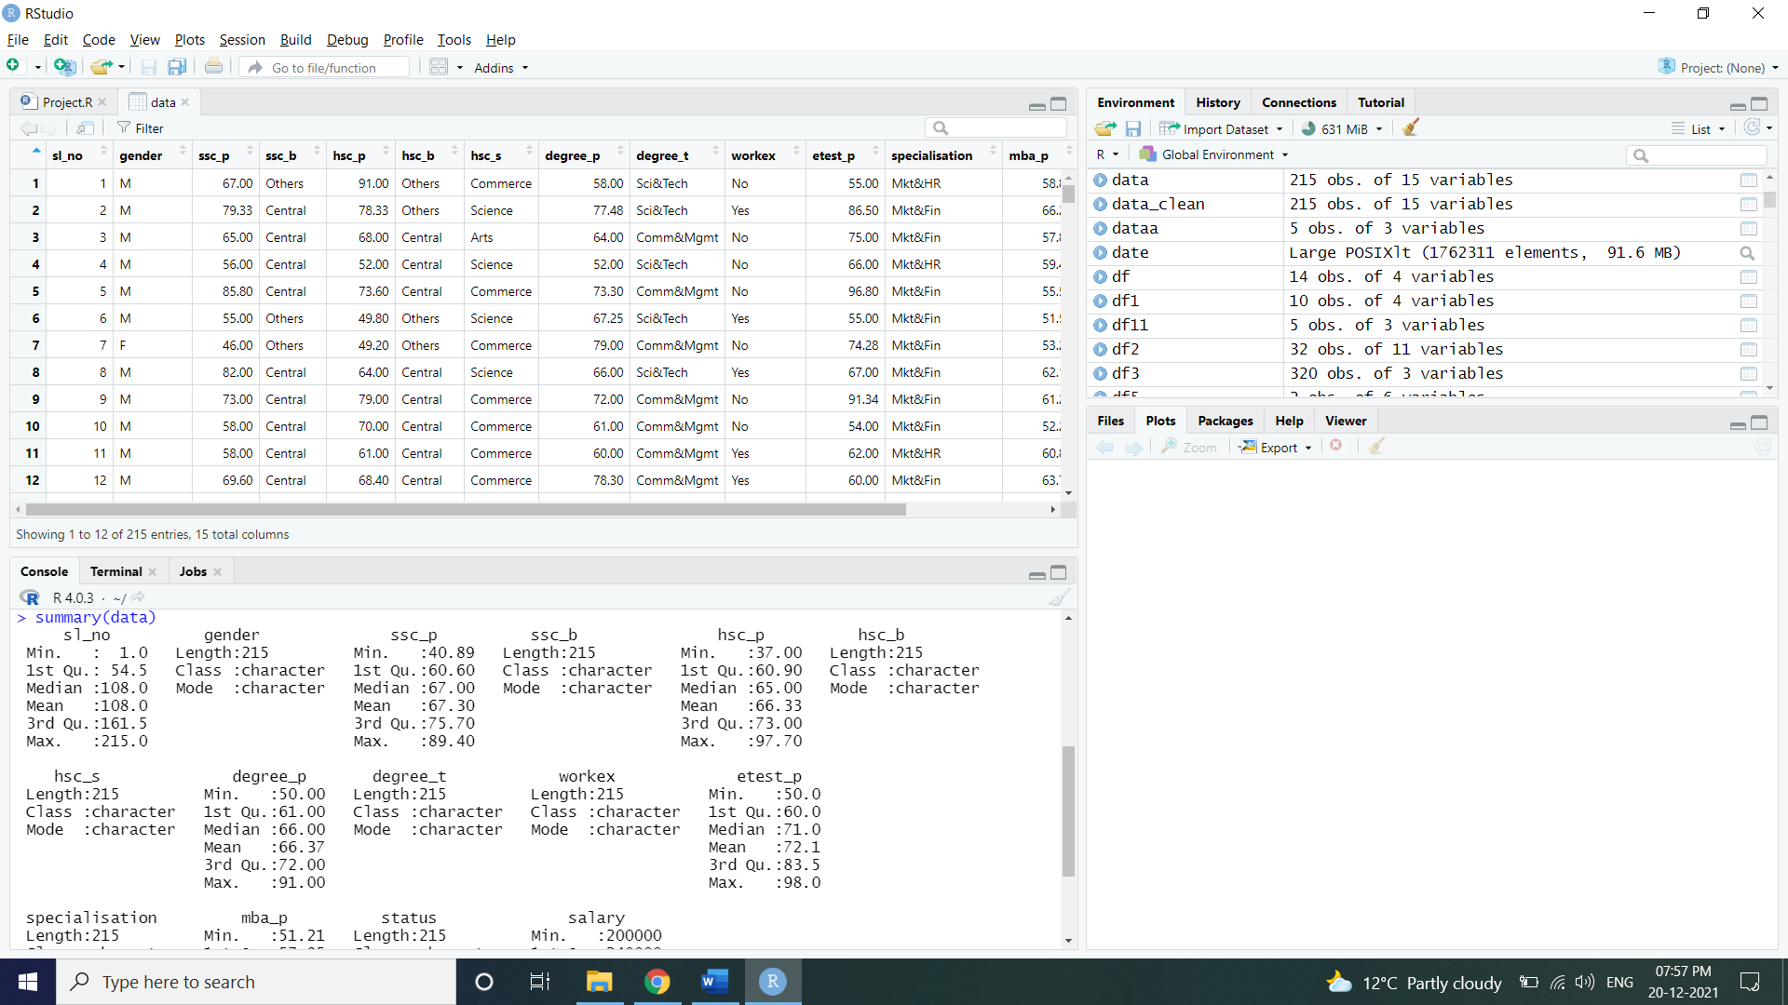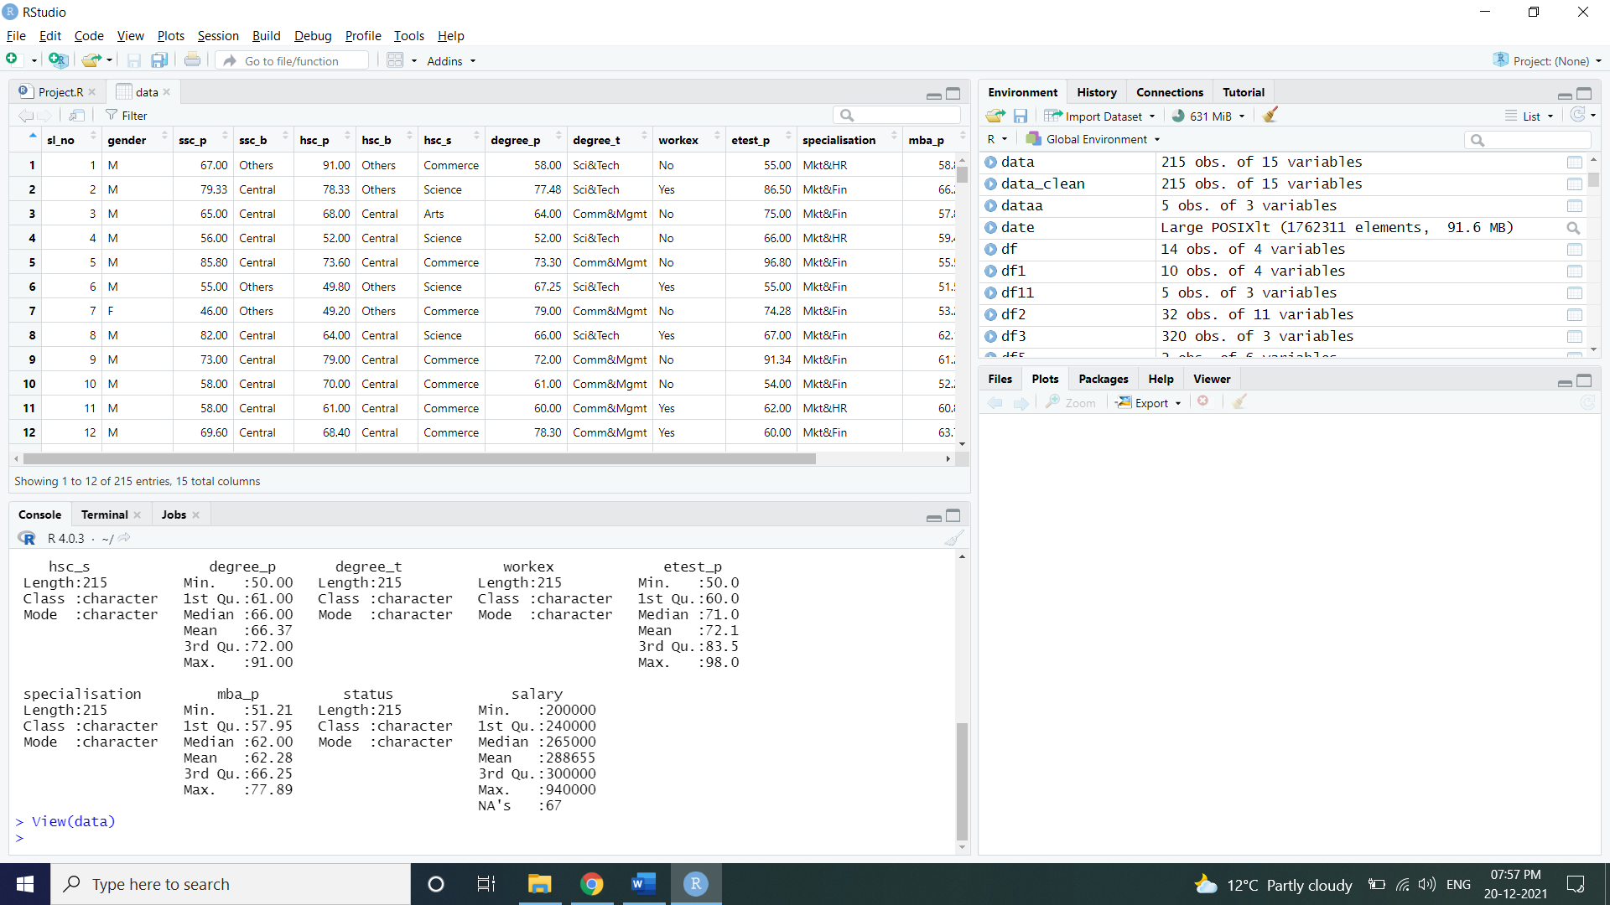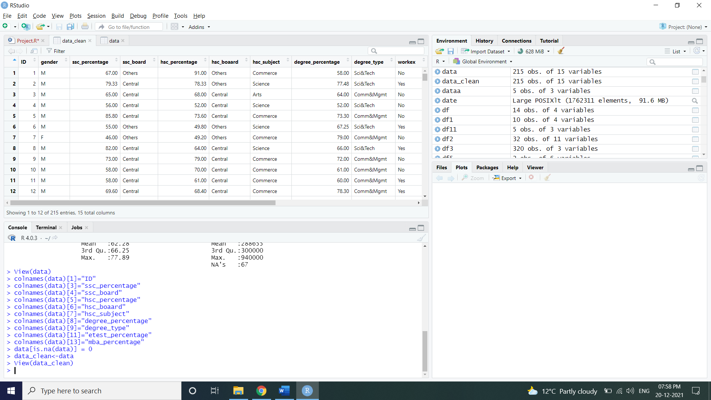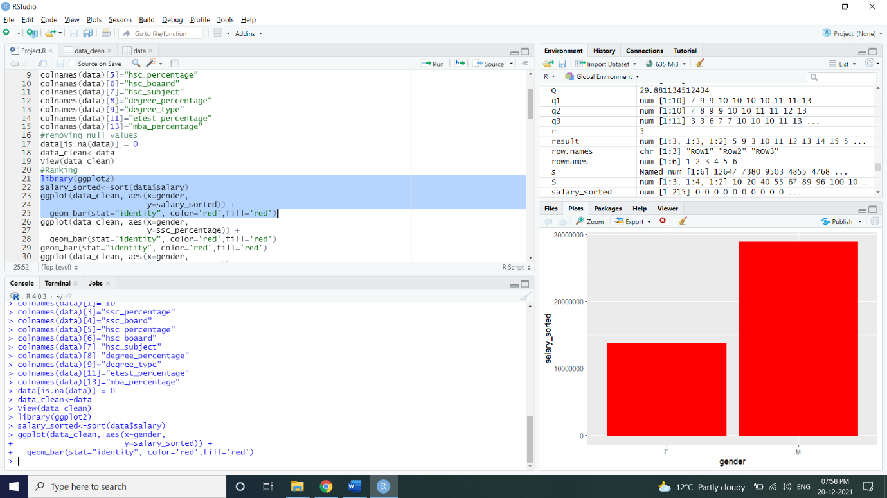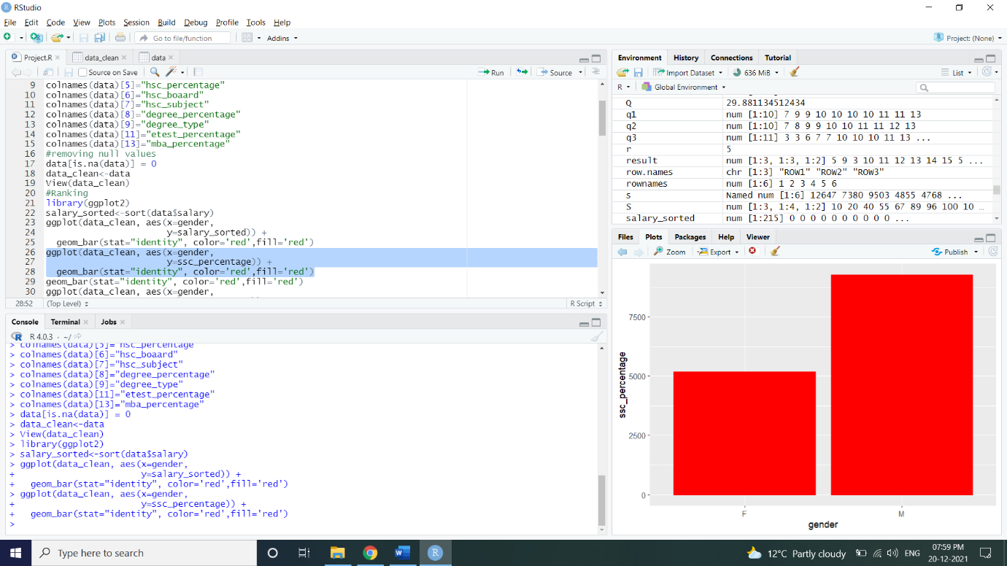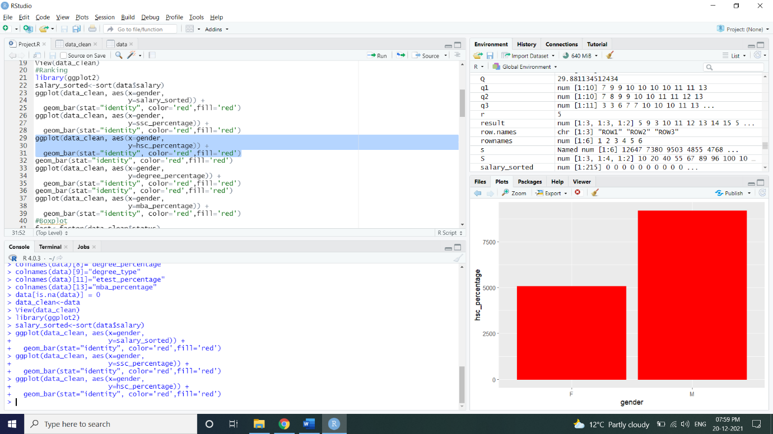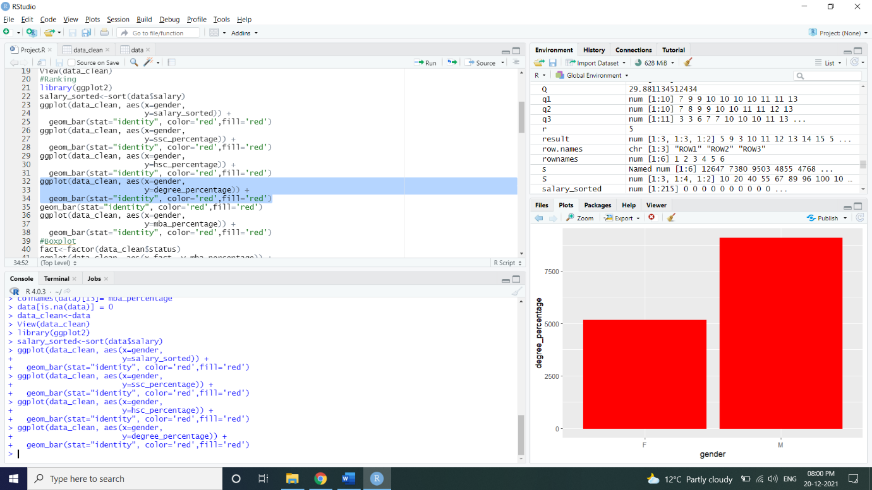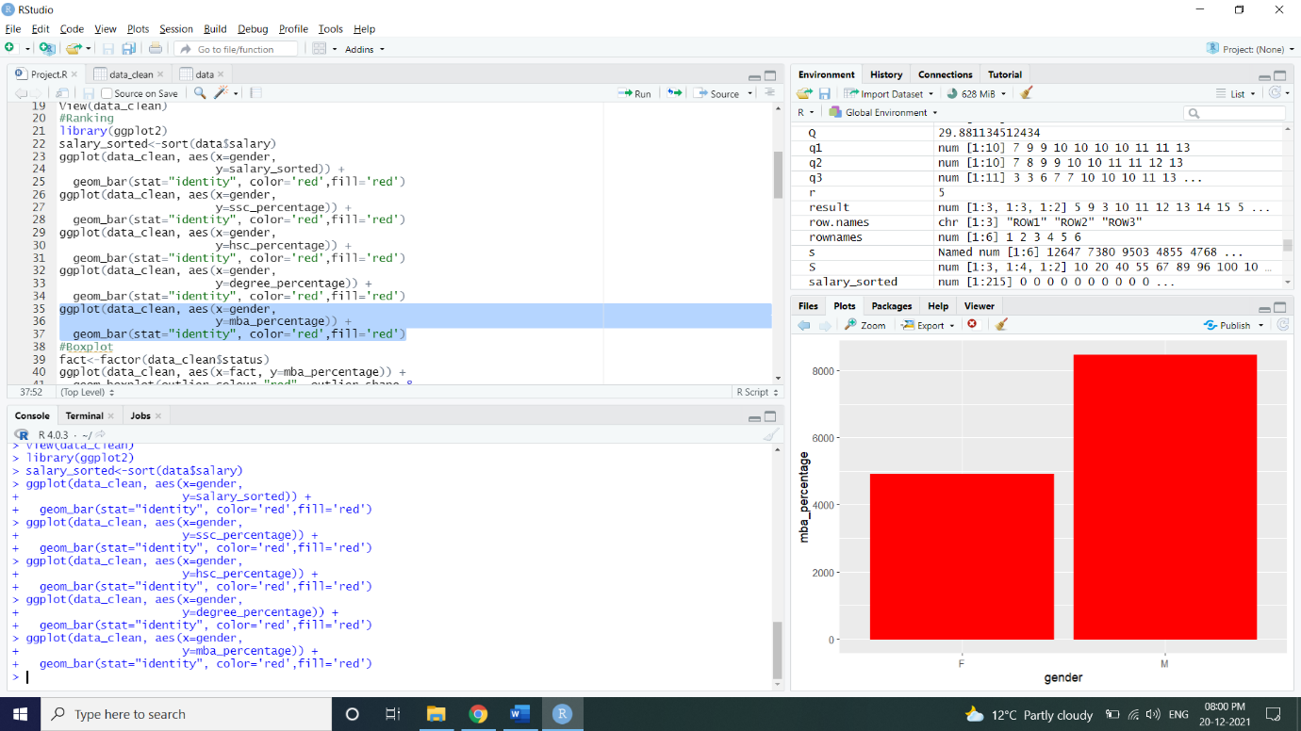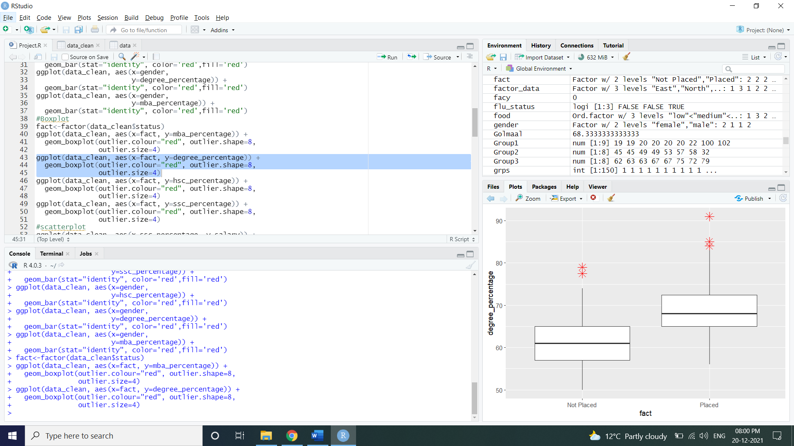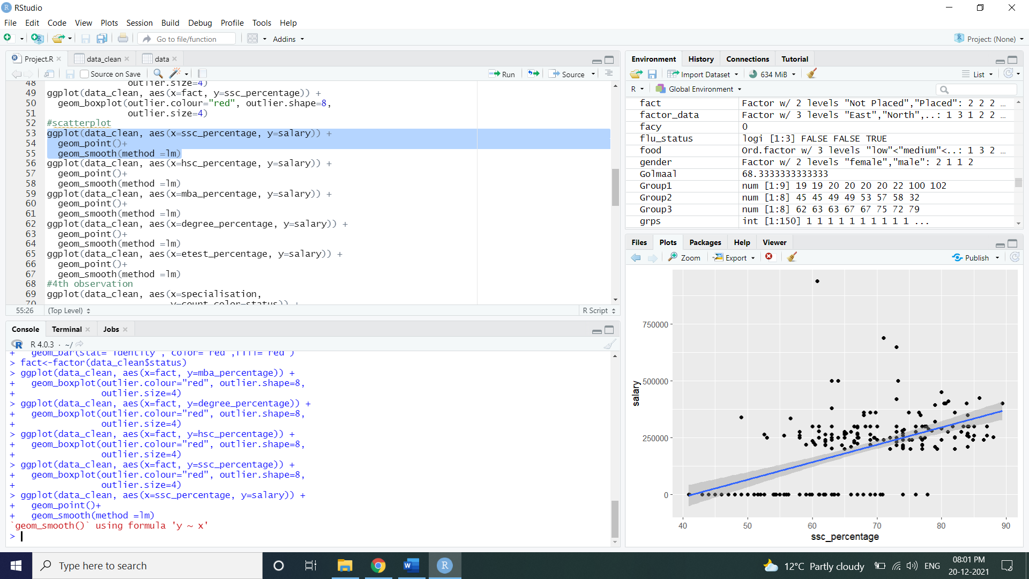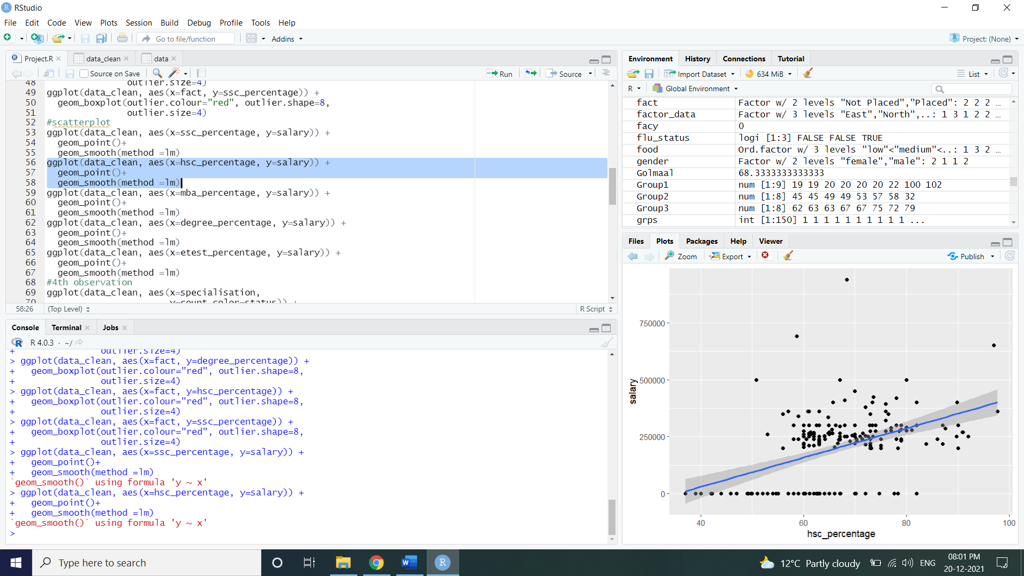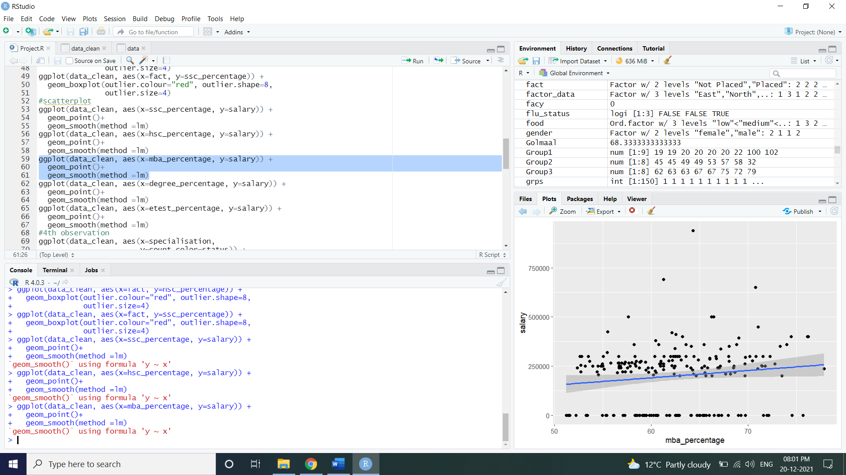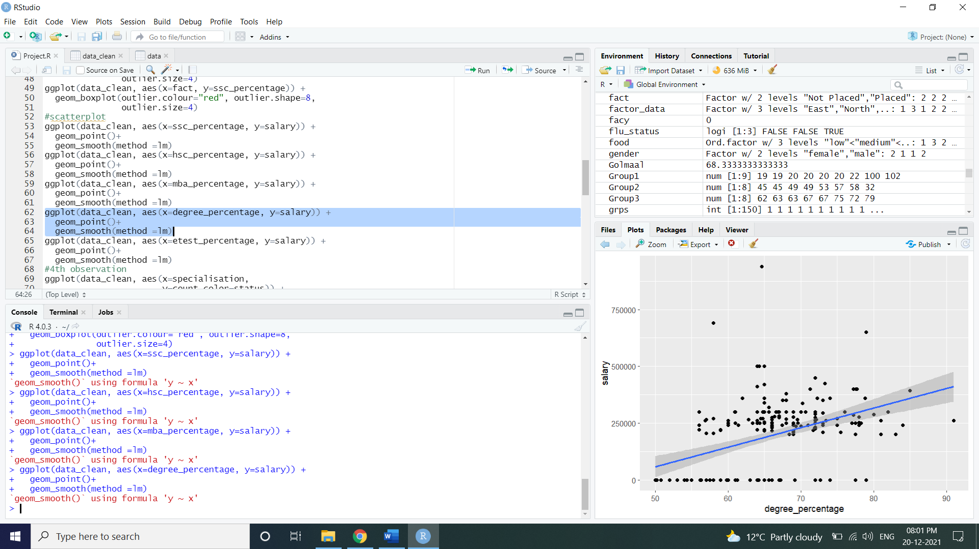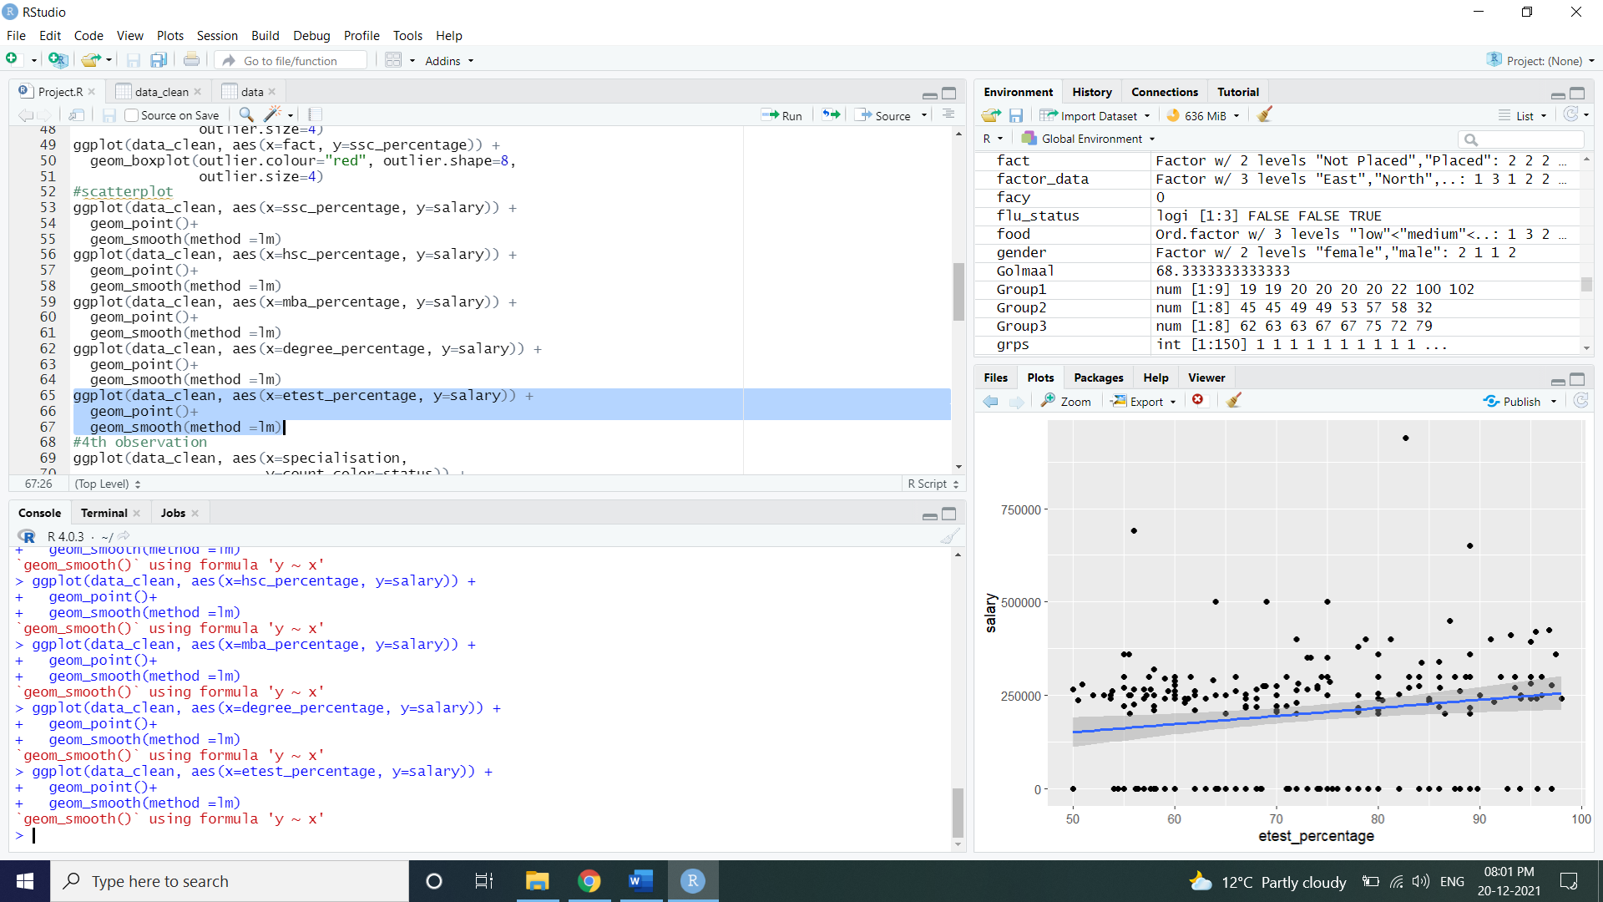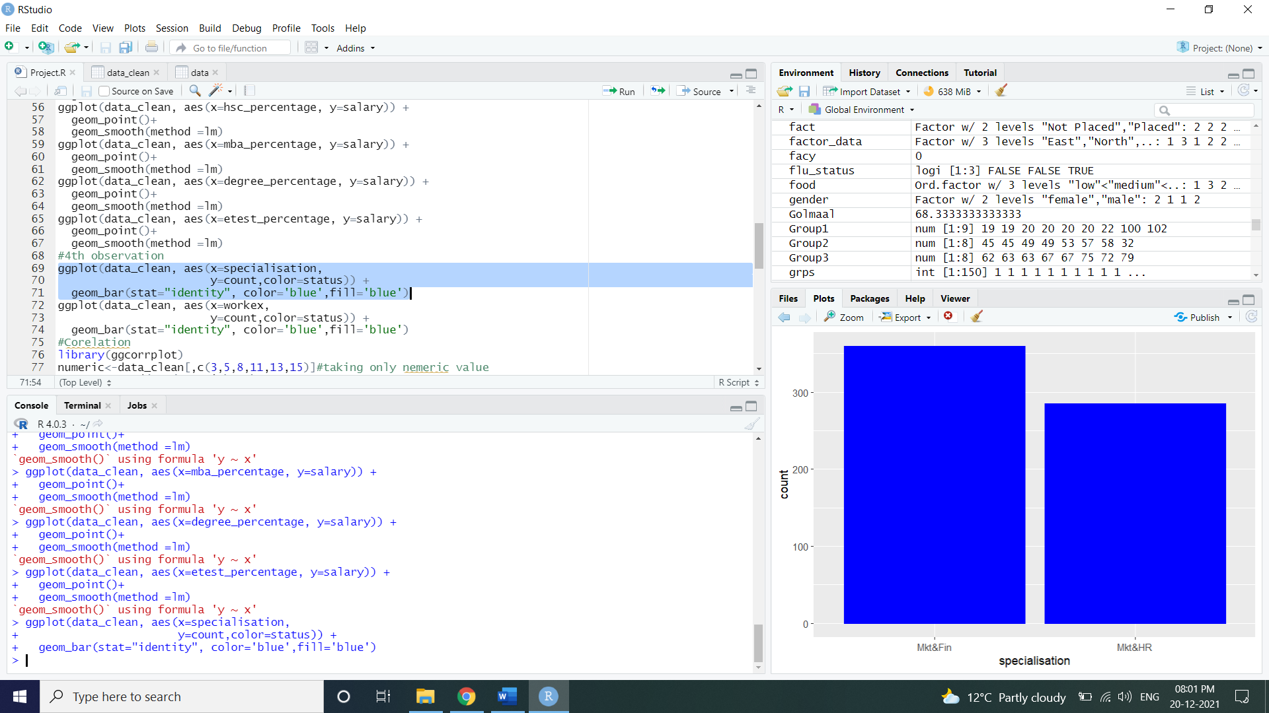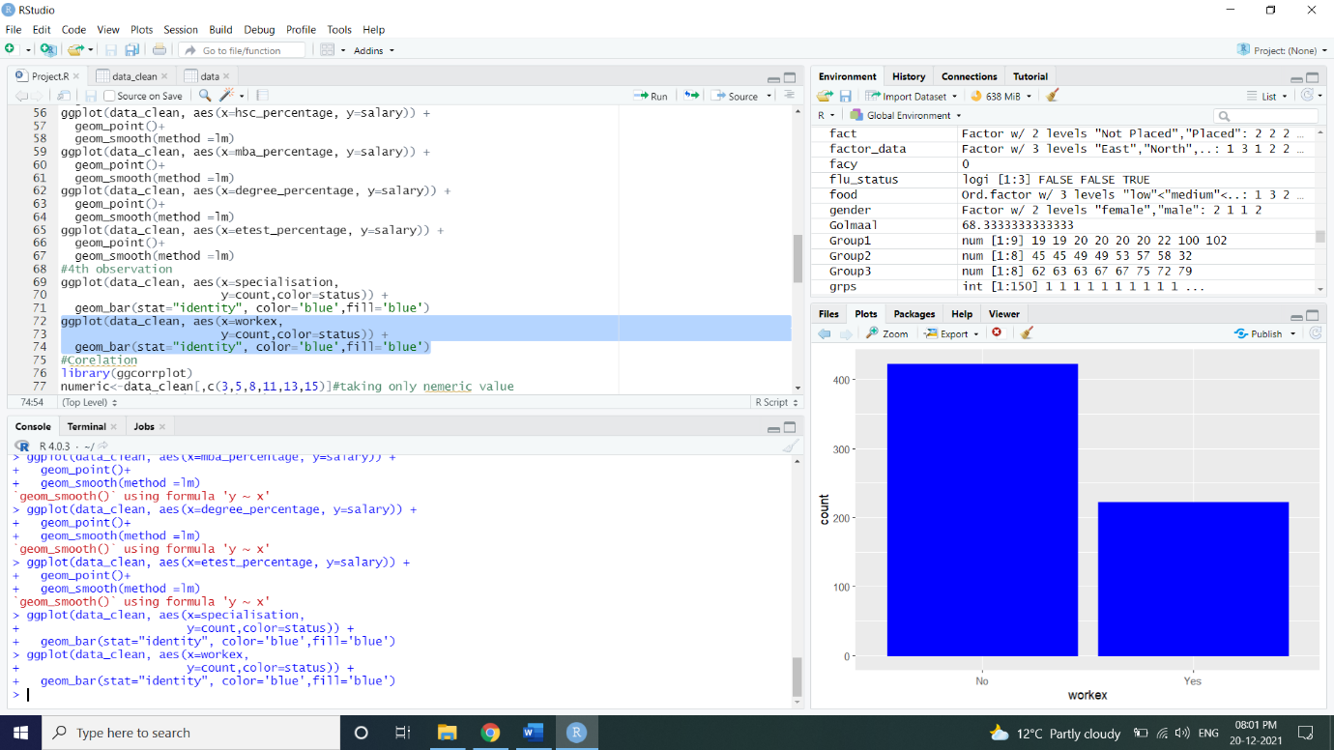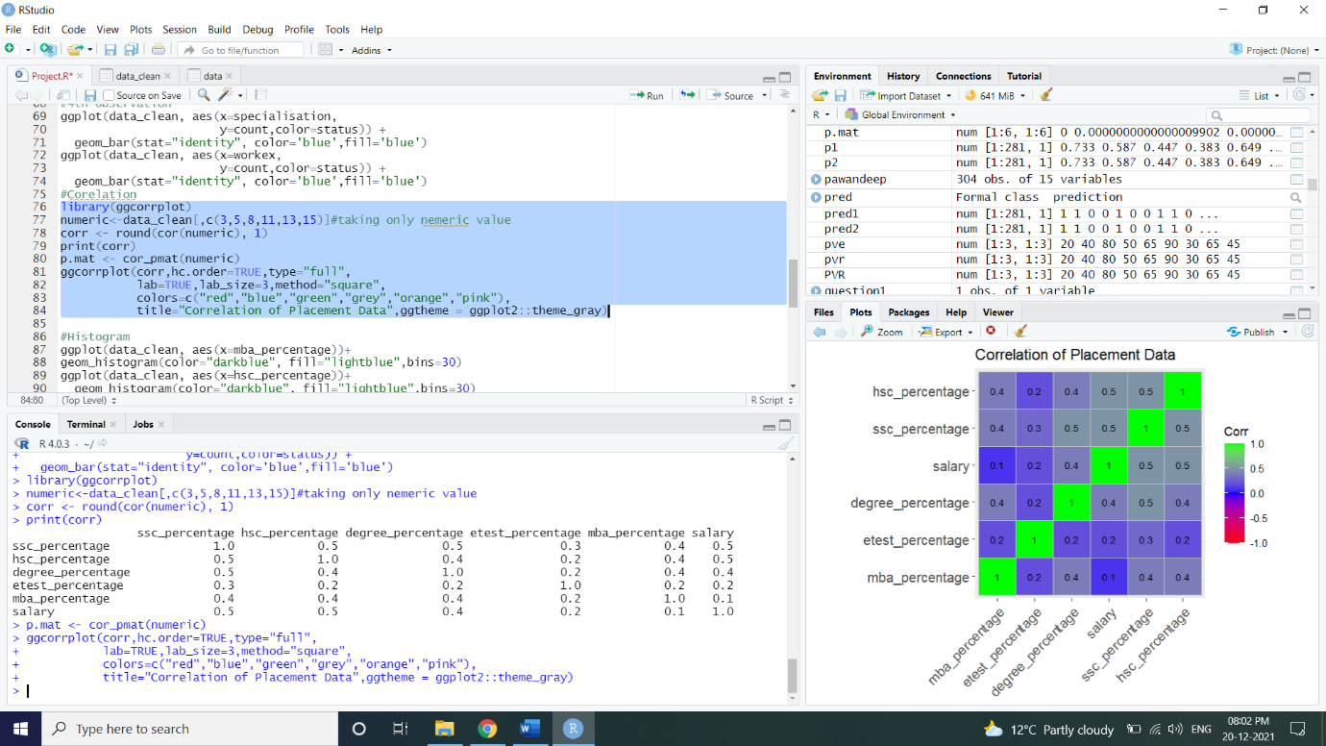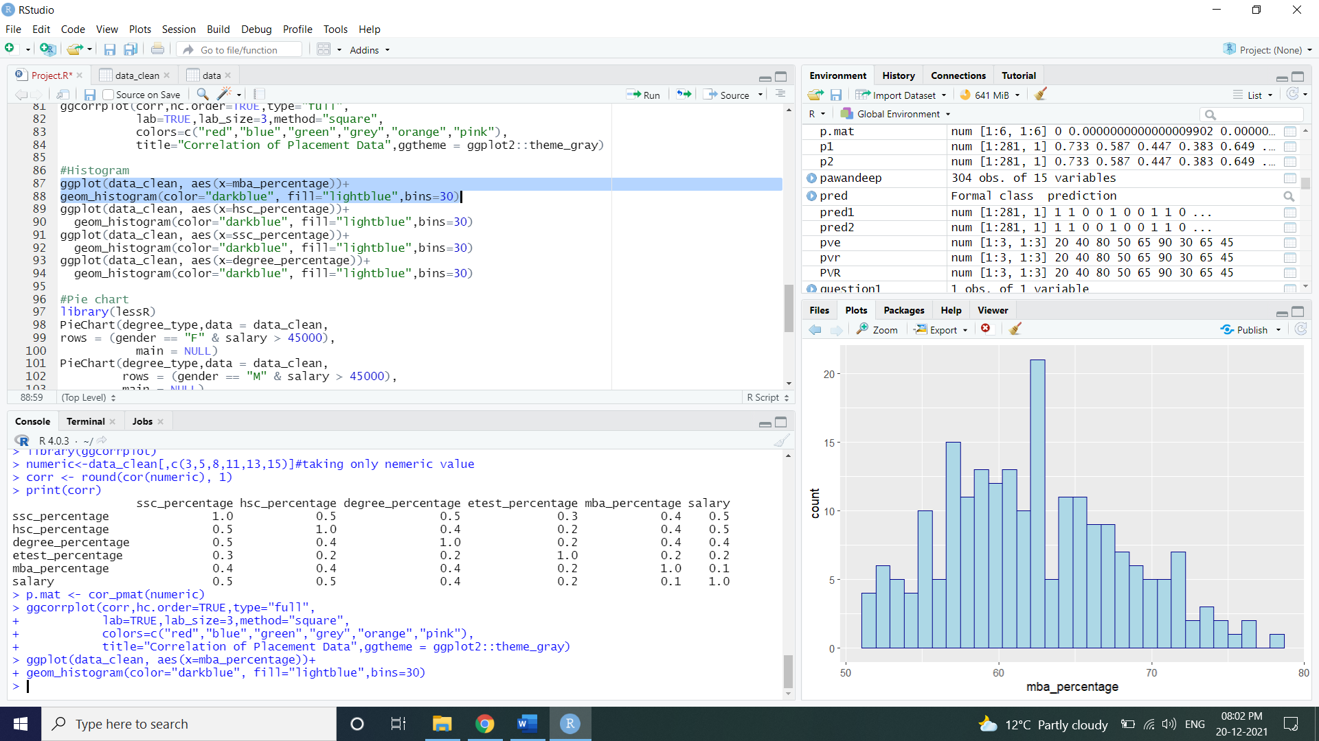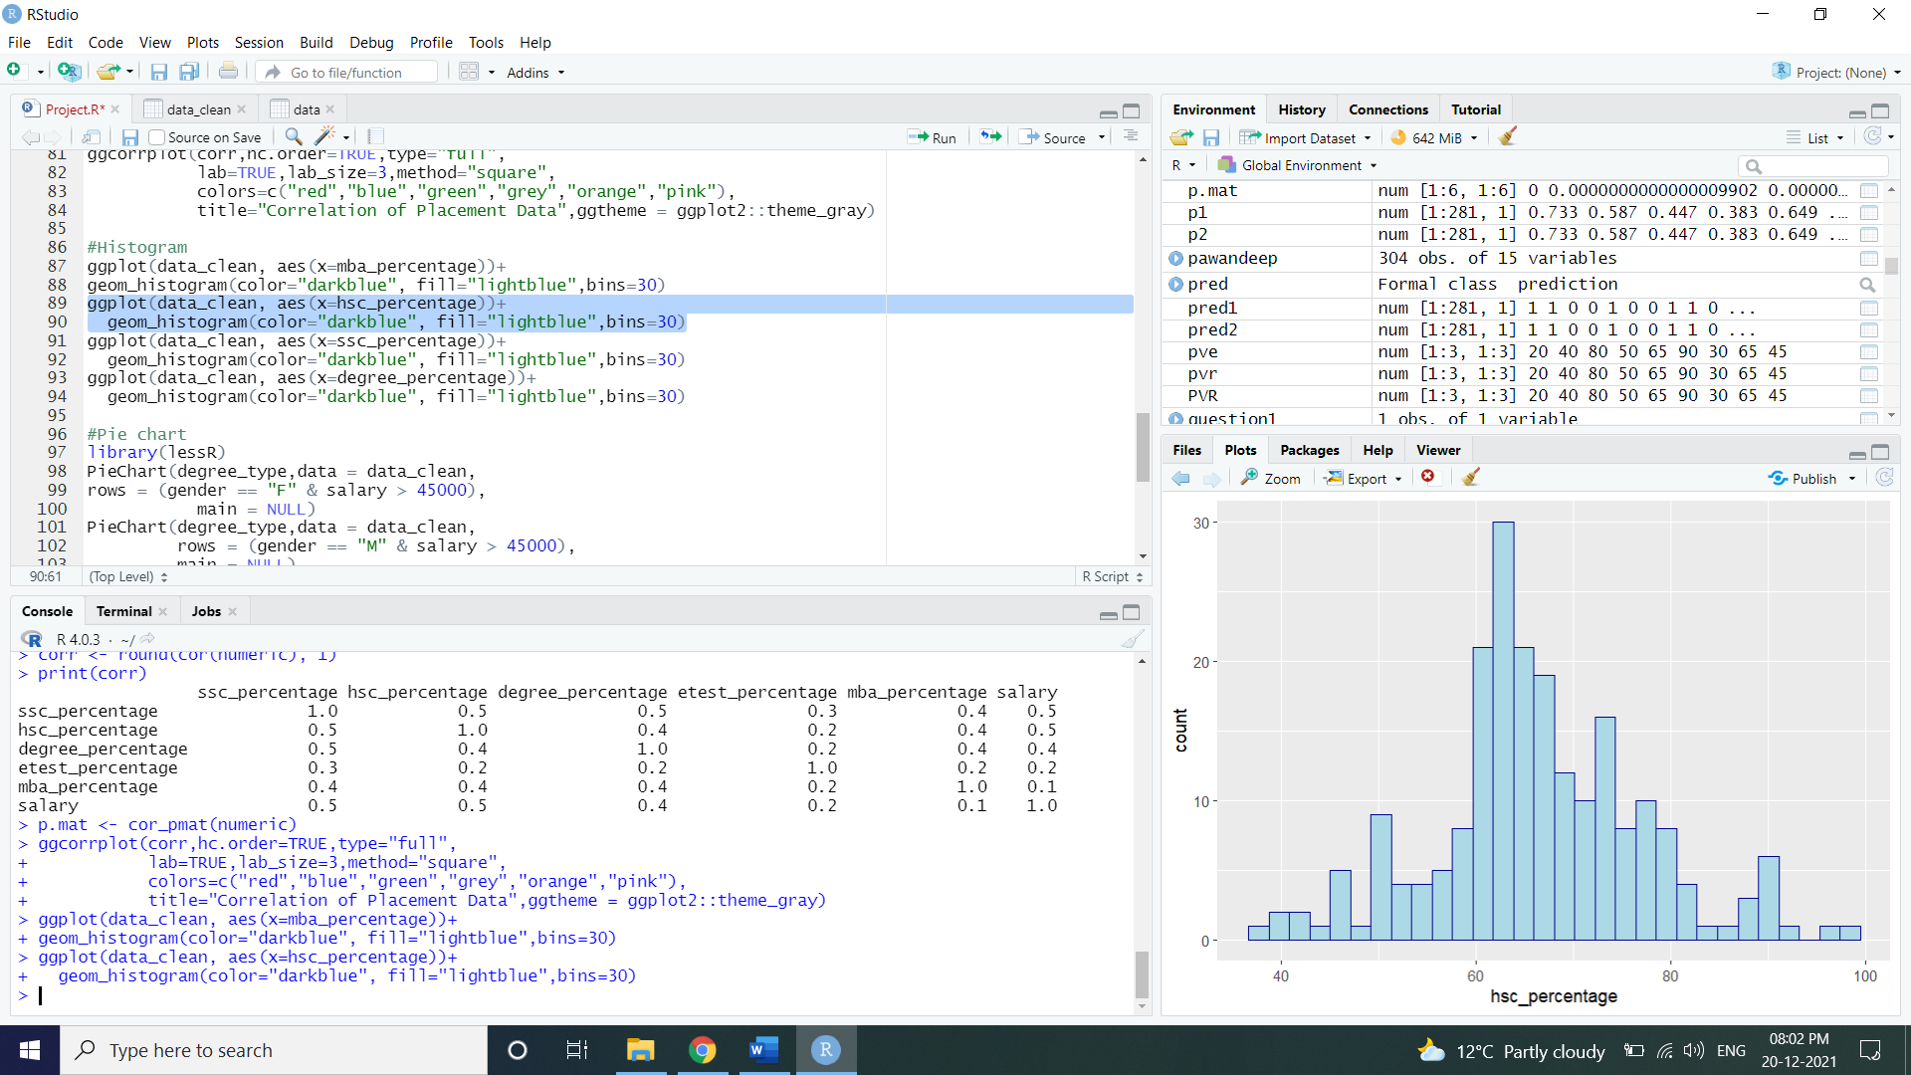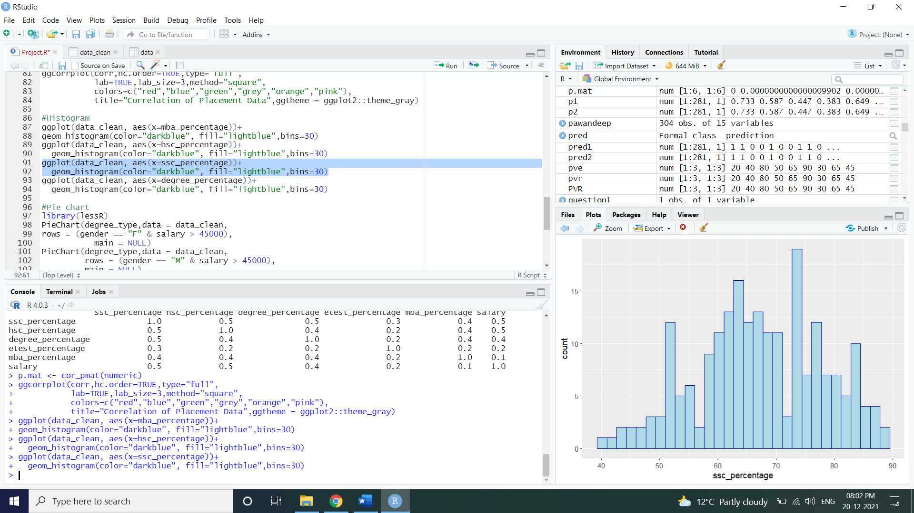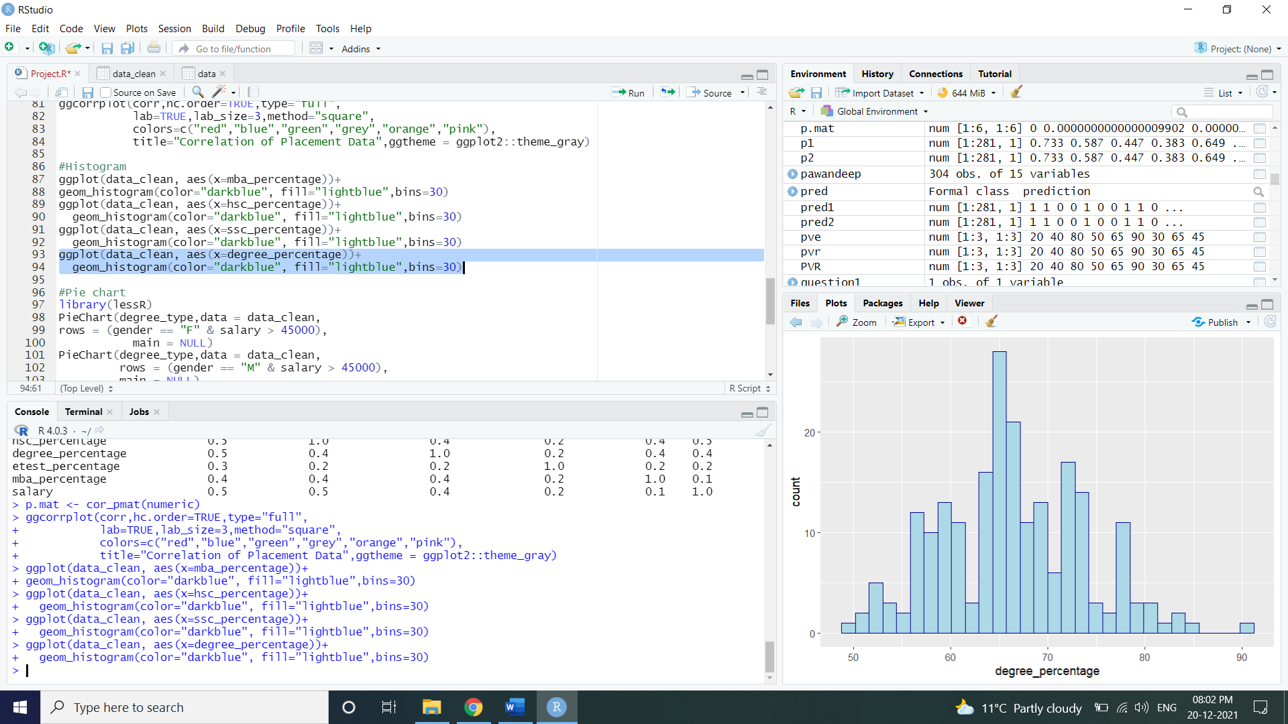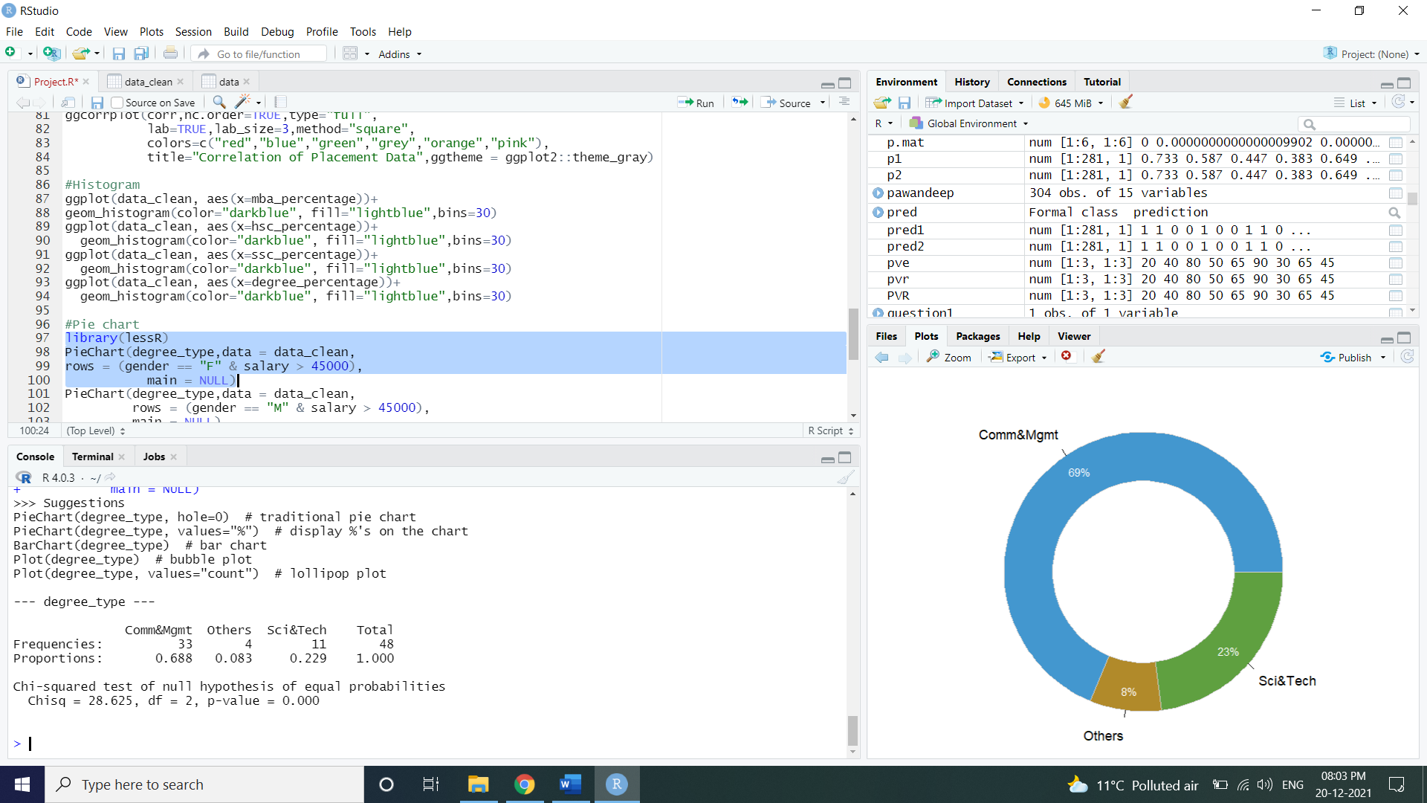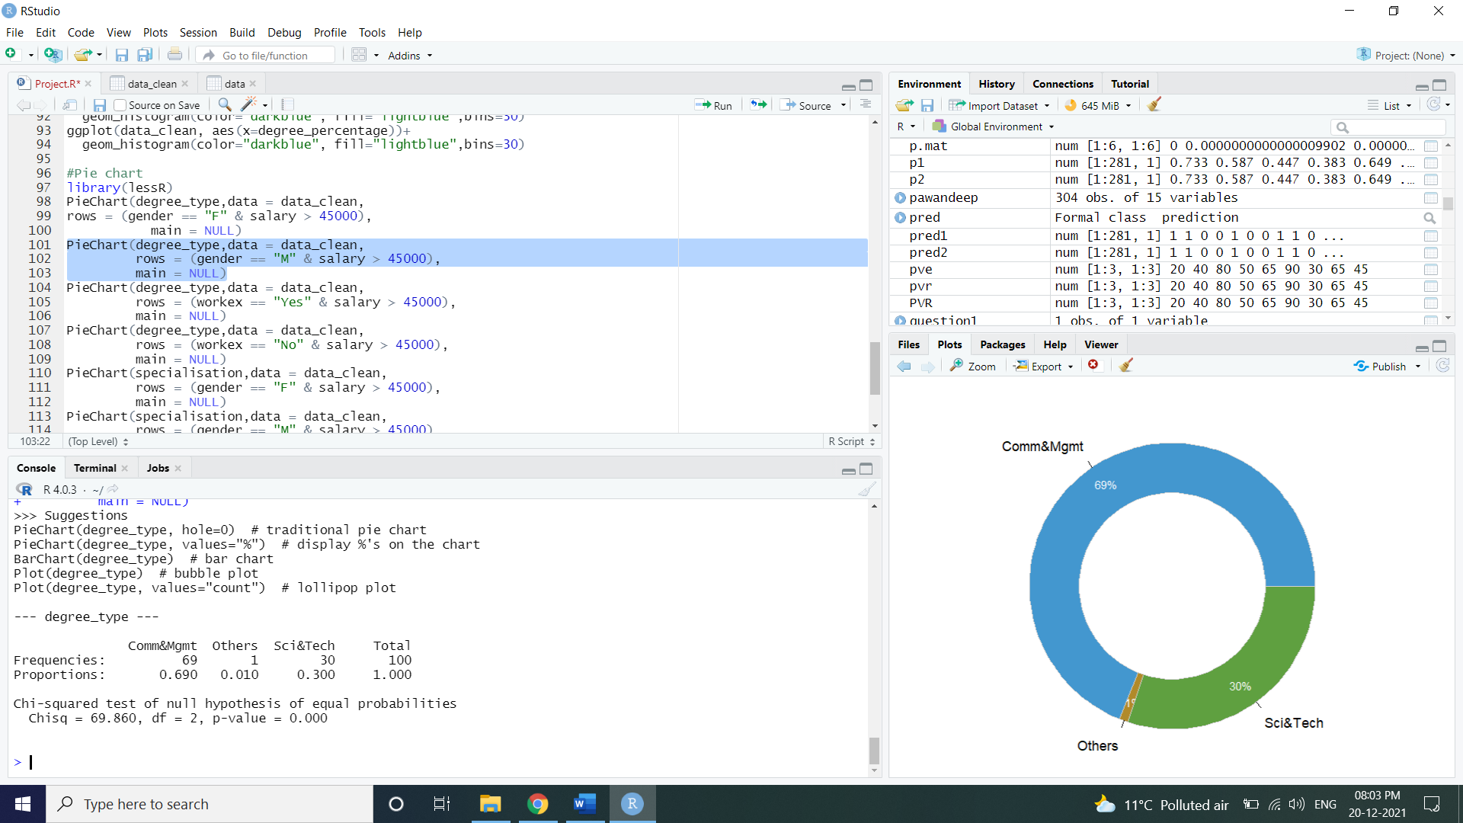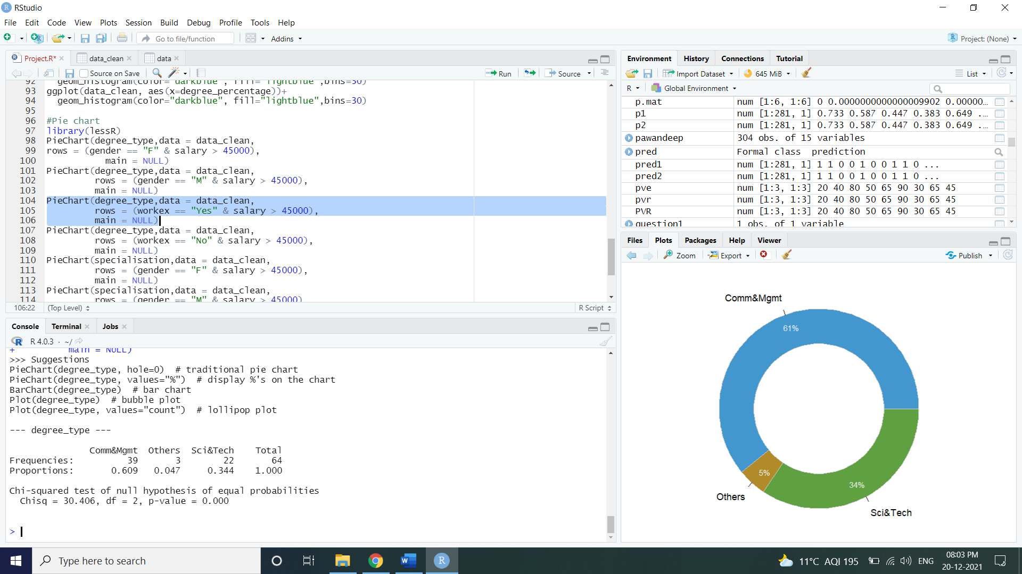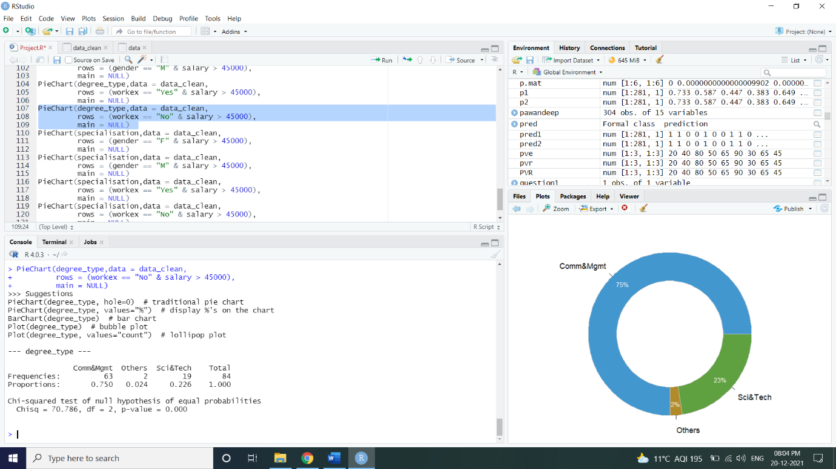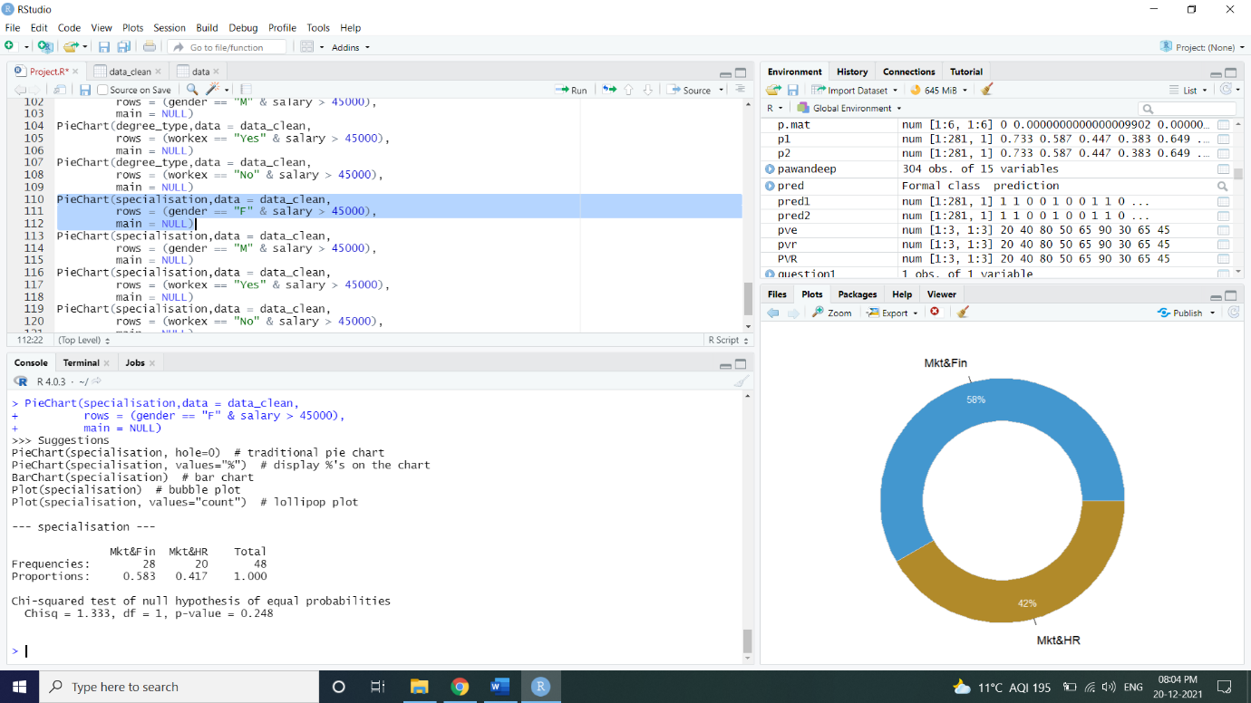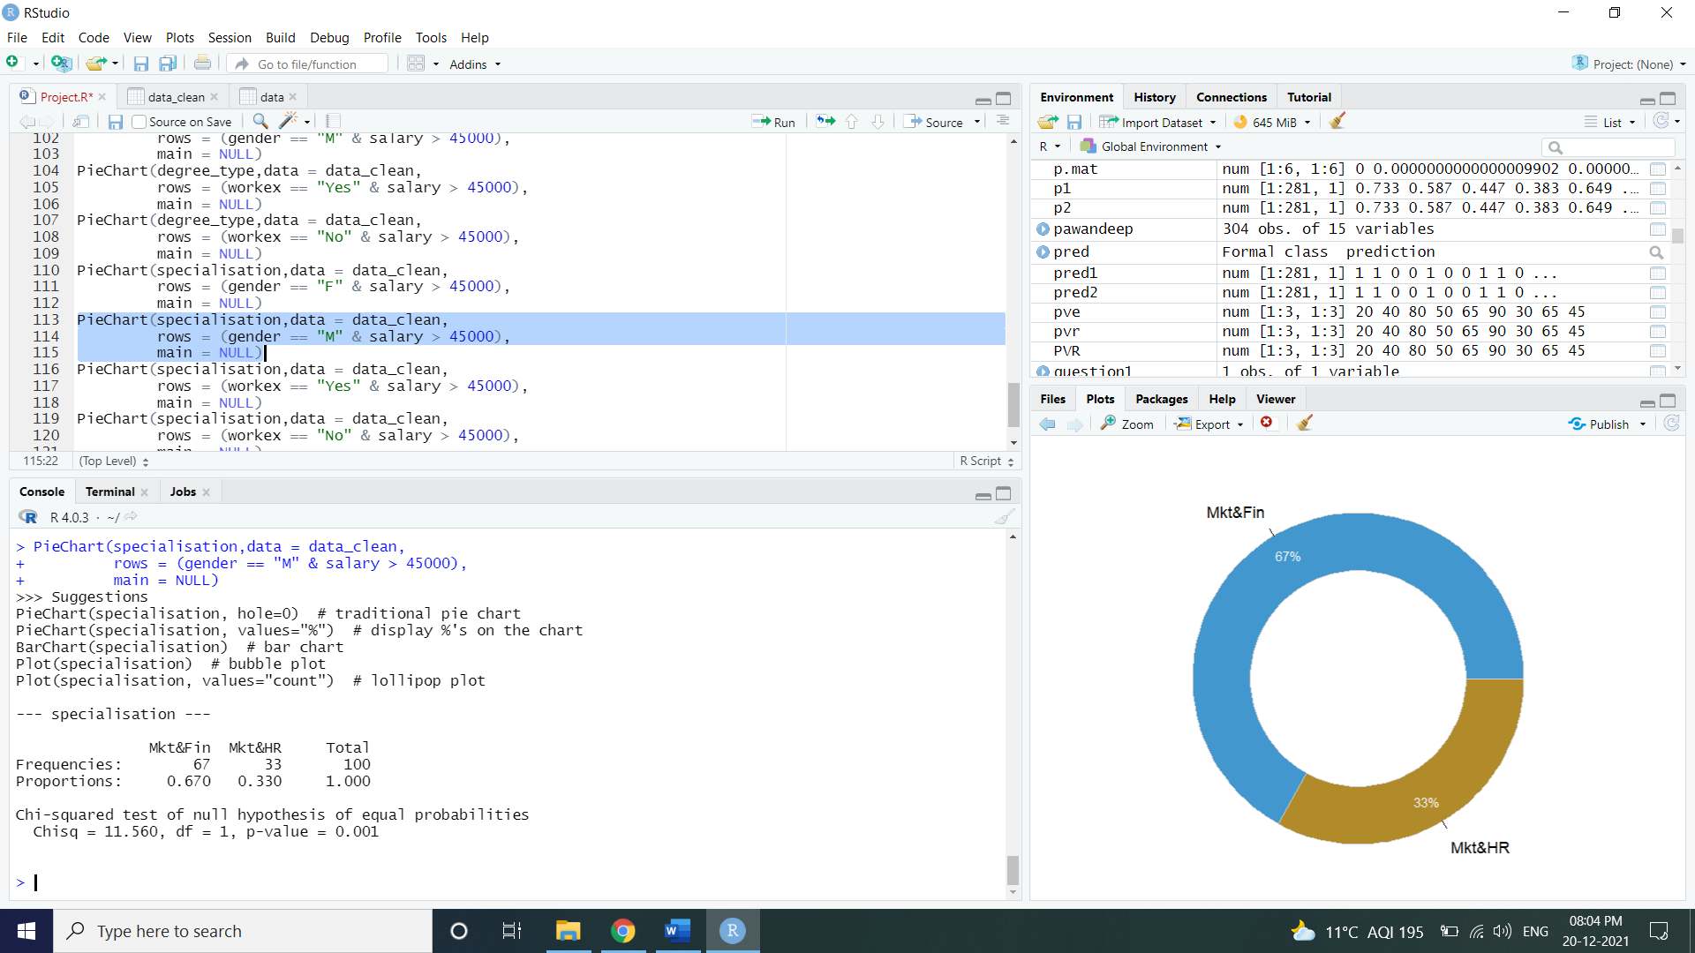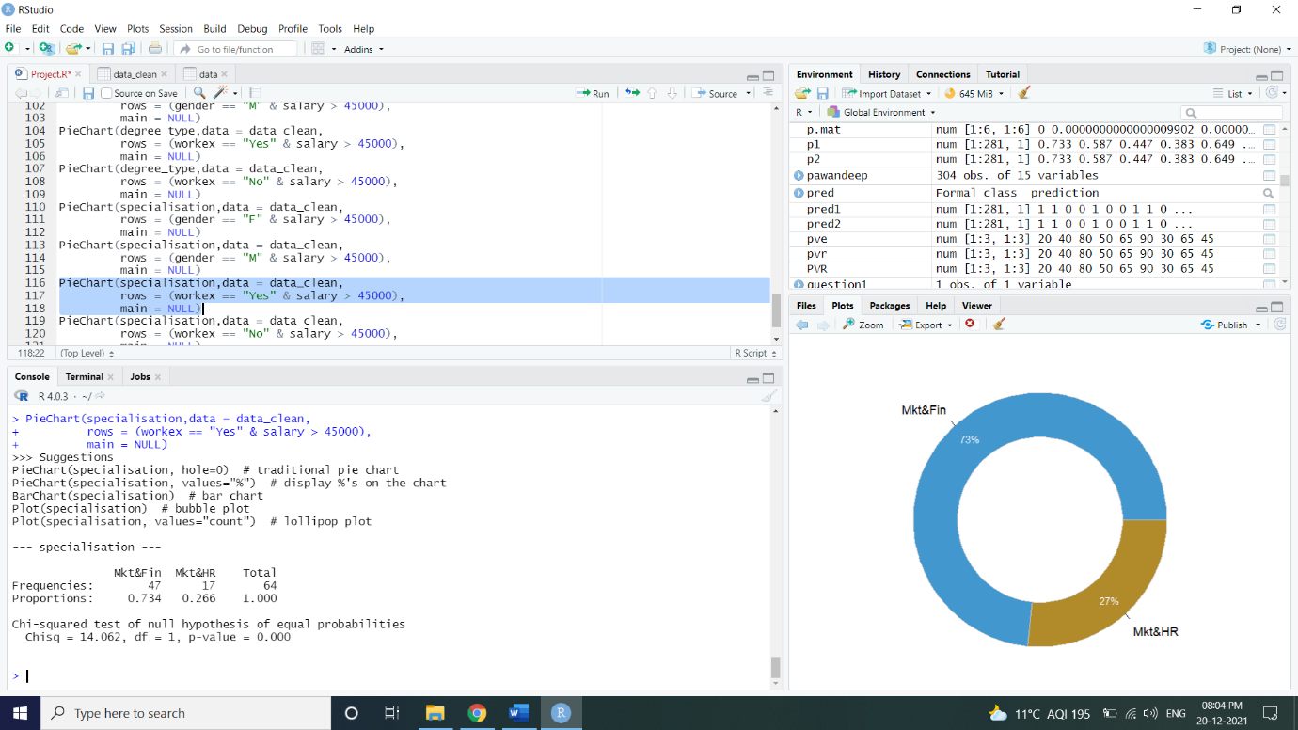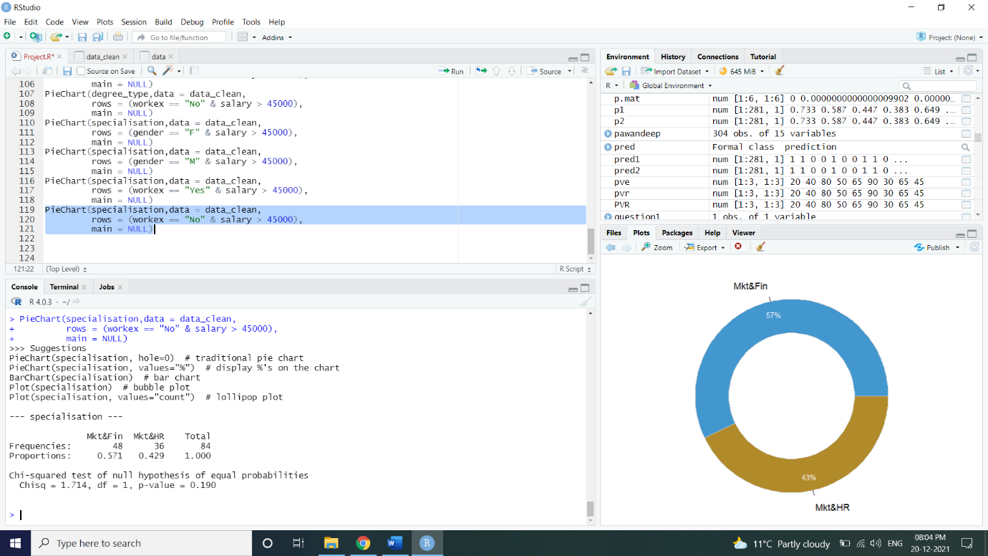

Then we are checking if there is any missing value in our dataset...

Then we are going to fill missing salaries with zero as they represent students who have not got placement offer...

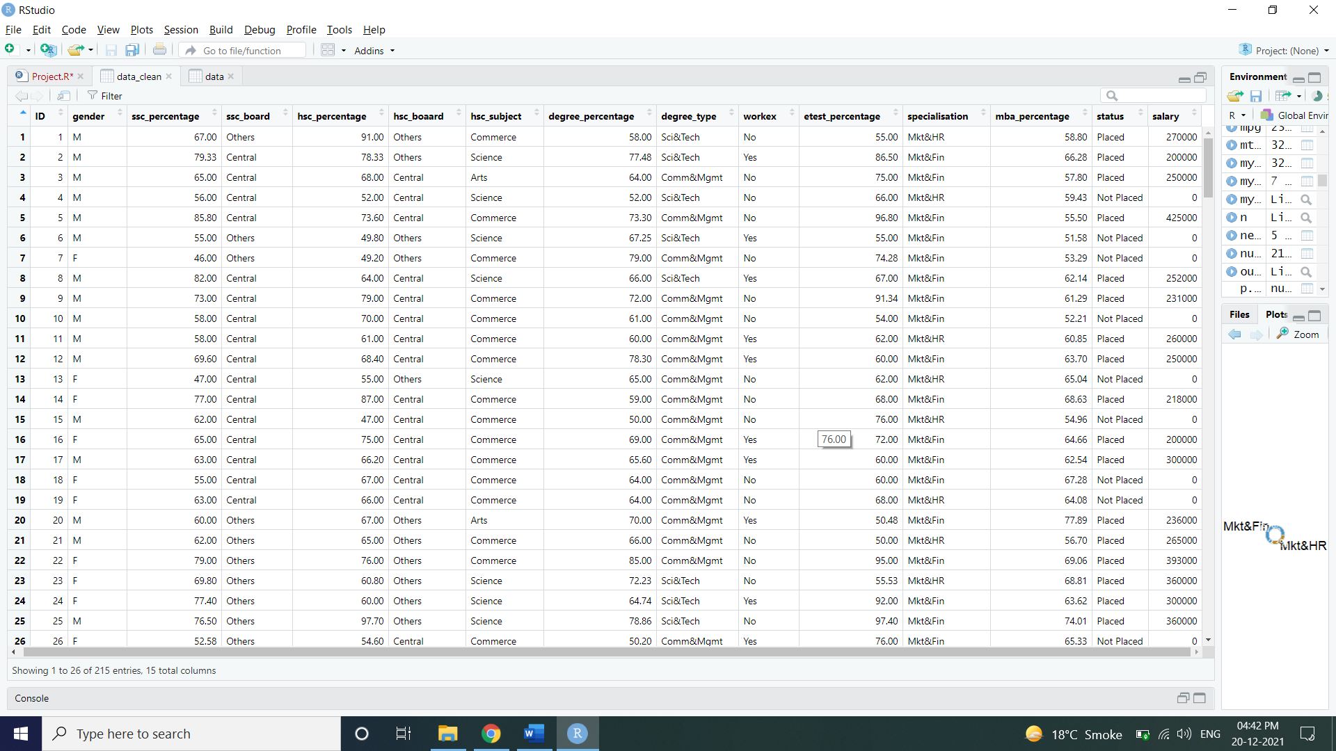

**Correlation:**

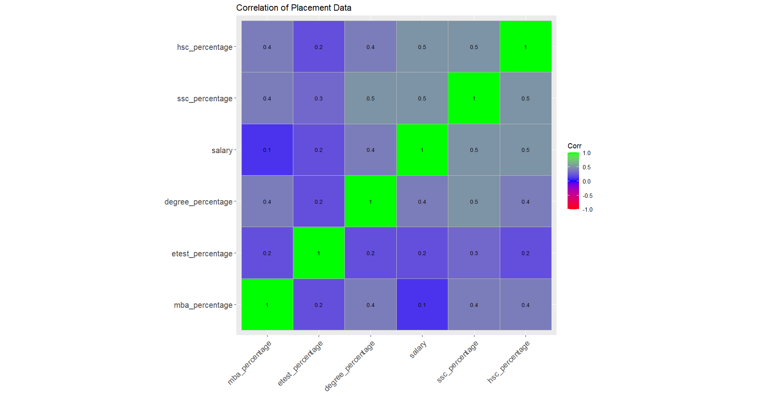

Now we are doing gender-based analysis...

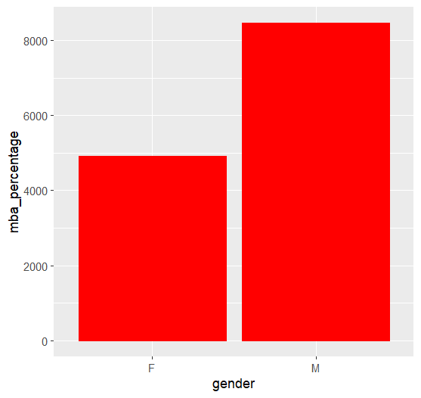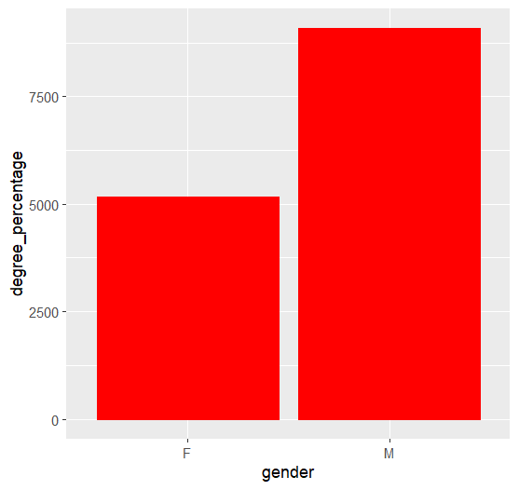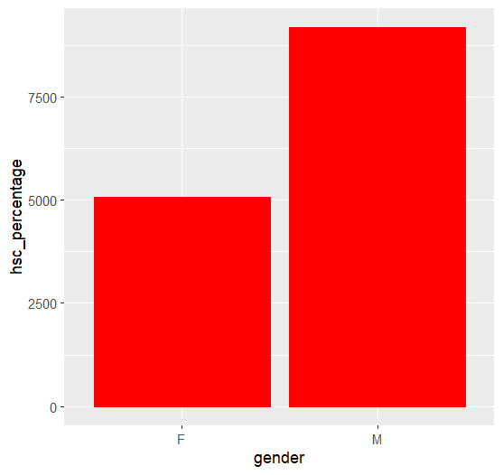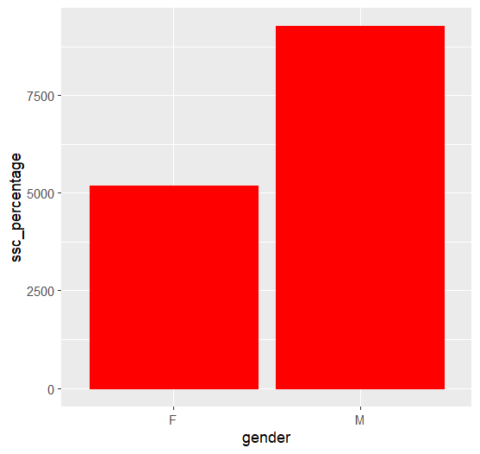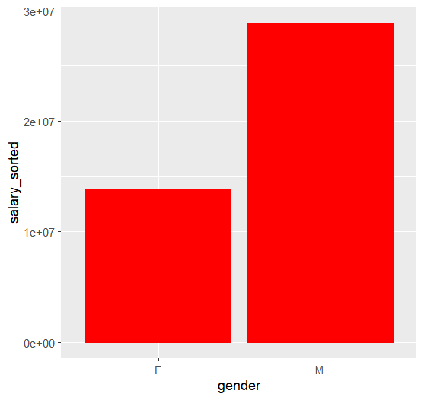

1st observation = in this visualisation we saw that man are given more salary even though women are scoring better the man.

Now we are doing Placement based analysis...

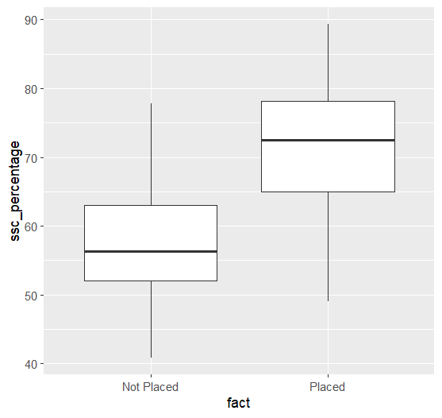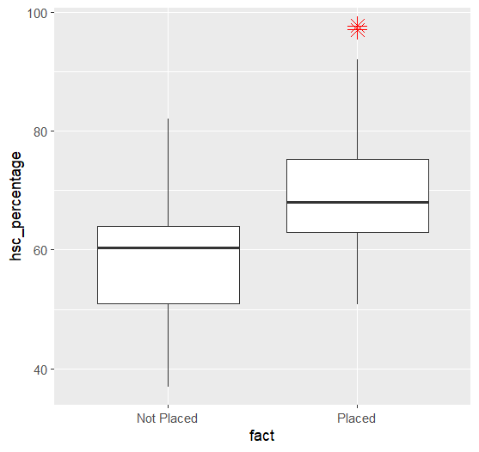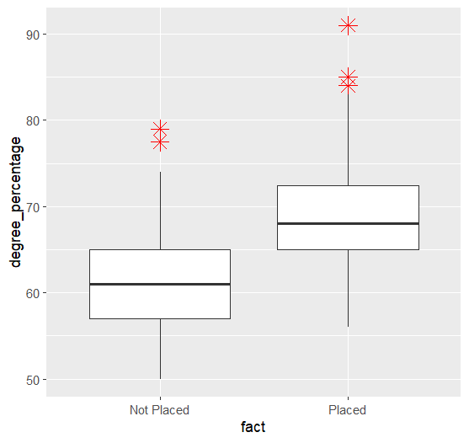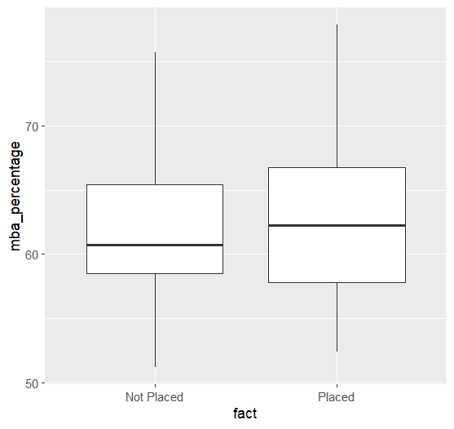

2nd observation - student with higher percentage better academic result can perform better during placement compared to those who are not getting higher percentage...

Now we are doing Salary VS Academic result analysis...

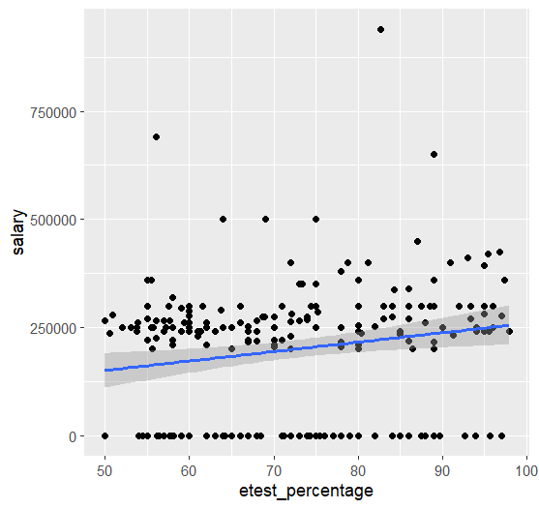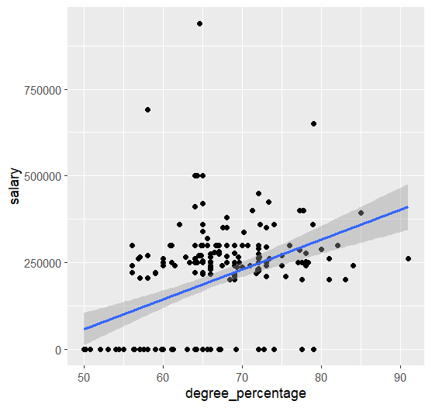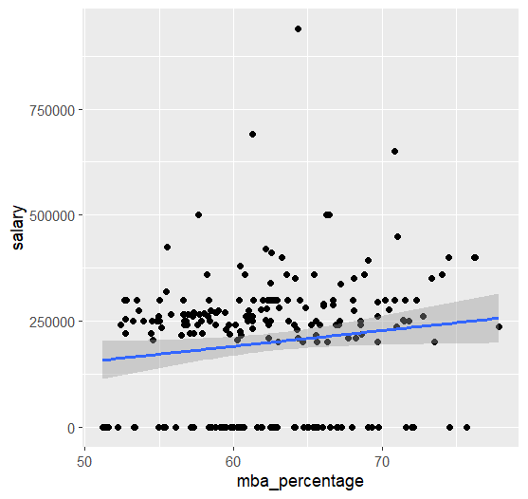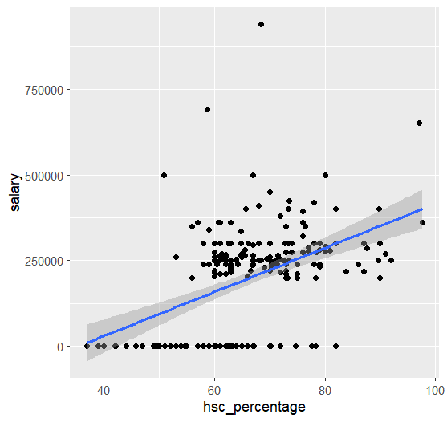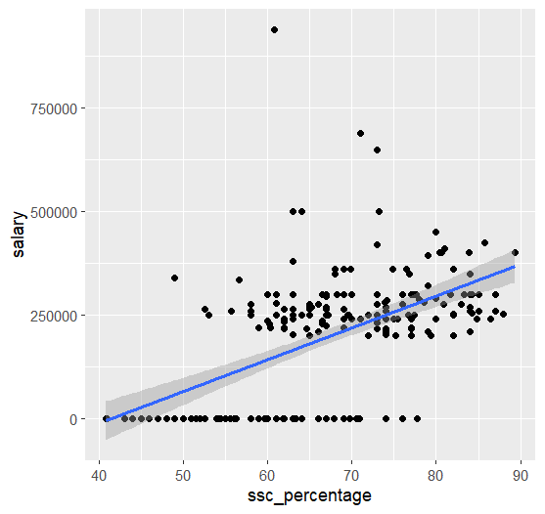

3rd observation = student with average percent of 60 to 70 percent are getting salary around 250000 INR annually. Higher percentage does not necessarily correspond to higher salary package...

Now we are analysing that does type of specialisation affect placement or not...

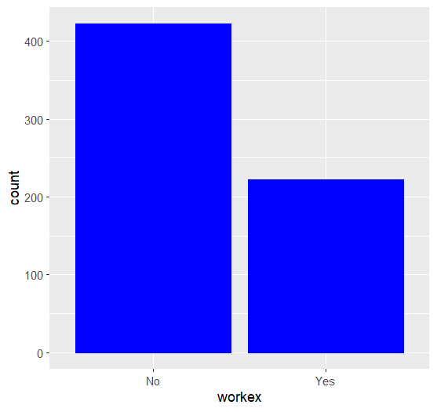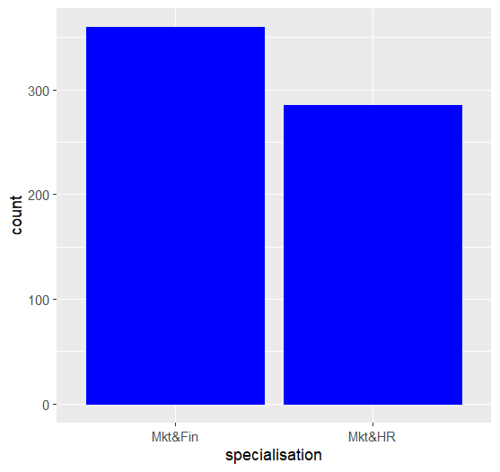

From here we see that, It seems like work experience has no effect on job placement...

Now, we are analysing that what percentage, maximum number of students got ….

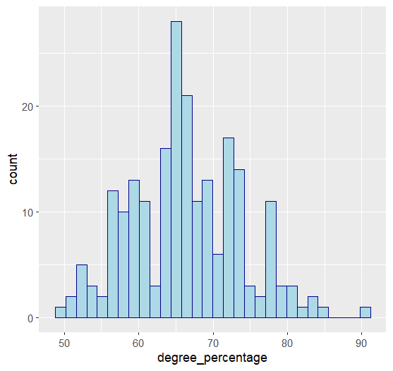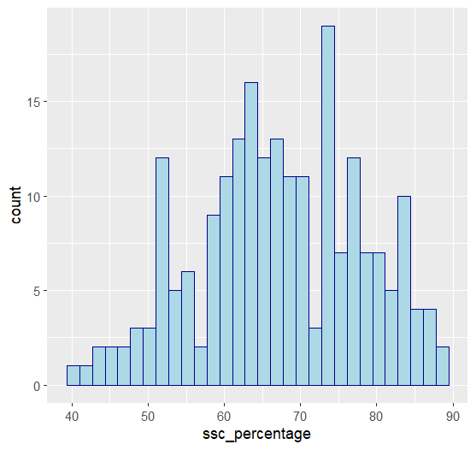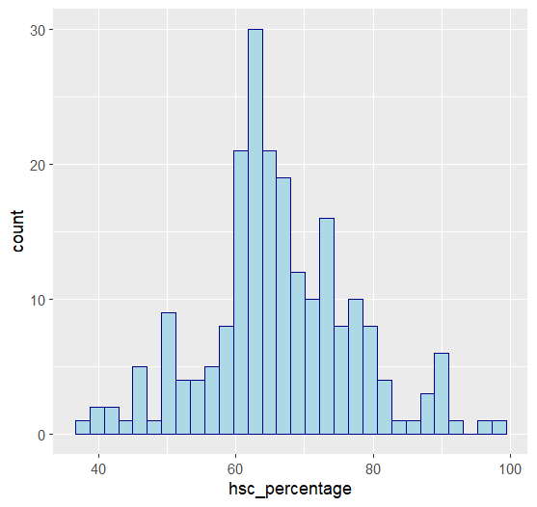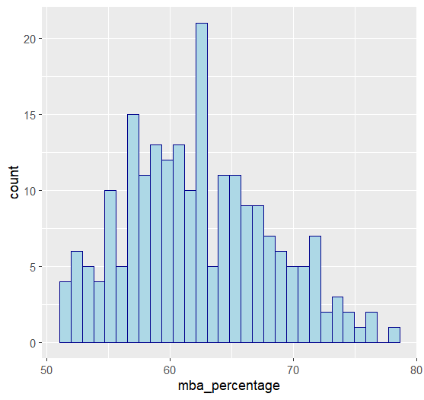

**From here, we see that, it seems like most of the student got percentage in between 60%-70%**

**Now we are analysing that:**

**a) In which degree type Female get more salary**

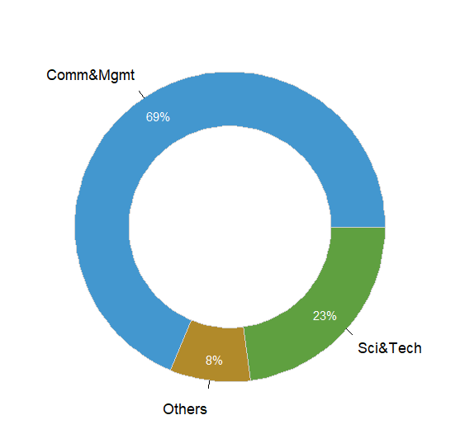

**b) In which degree type male get more salary**

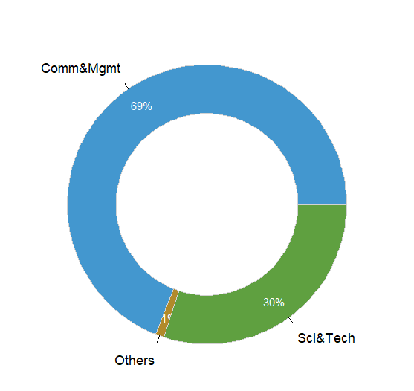

**In both cases ‘a’ and ‘b’ both male and female get more salary in commerce and management degree type.**

**c) In which degree type experience get more salary**

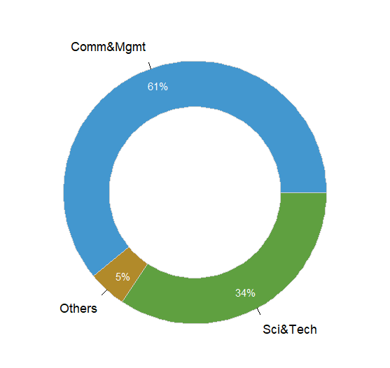

**In this case we conclude that experience get more salary in commerce and management degree type.**

**d) In which degree type fresher get more salary**

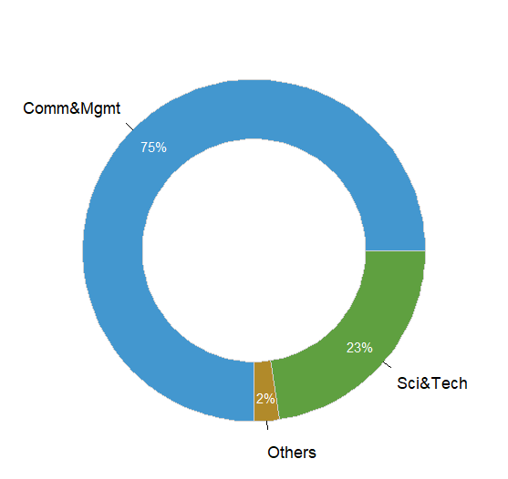

**In this case we conclude that fresher get more salary in commerce and management degree type.**

**e) In which specialisation type Female get more salary**

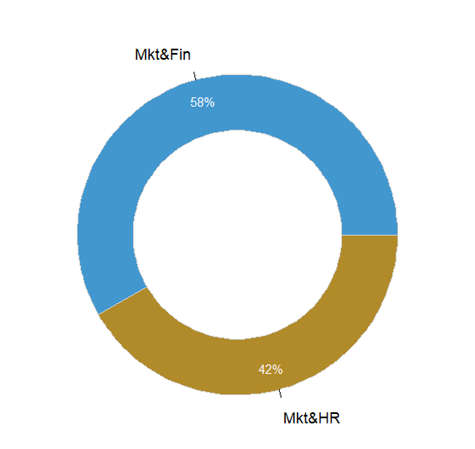

**In this case we conclude that female get more salary in marketing and finance**

**f) In which specialisation type male get more salary**

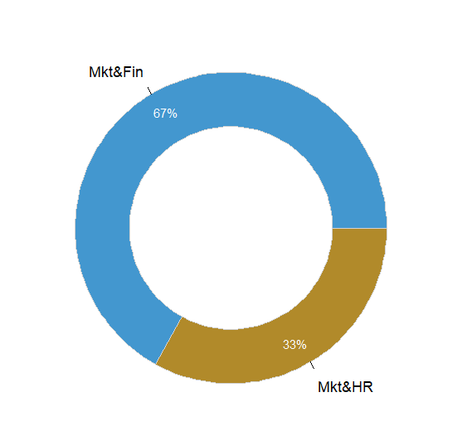

**In this case we conclude that male get more salary in marketing and finance**

**g) In which specialisation type experience get more salary**

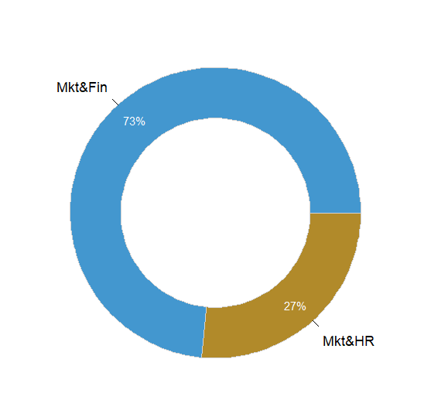

**In this case we conclude that experience get more salary in marketing and finance**

**h) In which specialisation type Fresher get more salary**



**In this case we conclude that fresher get more salary in marketing and finance**

**Conclusion:**

Finally, conclusion is that it seems like academic results have limited effect on securing a job placement. Specialisation seems to play a much more important role. Males have a better chance of getting chosen for the job placement. Males also have a better chance of getting higher pay.

We also conclude that commerce and management degree type get more salary and marketing, and finance specialization get more salary.